**INTERNSHIP REPORT**

**Project Name:** India Trade Analysis

**Internship Provider:** Grownited Private Limited

**Internship Objective-**

During my summer internship, I, Dhruvi Desai, a student of Computer Science and Engineering (AI-ML) at the Adani Institute of Infrastructure and Engineering, had the opportunity to engage in a comprehensive project involving dataset analysis, teamwork, Power BI, and Jira software. My primary focus was on analyzing the export and import values of our country.

This project was Guided by Alakh Pandya Sir, my main task was to gather and analyze data on export and import products from 2010 to 2021. This involved assessing the profitability and growth trends, as well as performing a detailed commodity-wise analysis for Grownited Private Limited.

**Requirement-**

The objective was to obtain a summarized view that allows users to easily access India Trade data from 2010 to 2021. This enables traders to easily analyze the effects of import and export values on growth and profit. The goal was to extract significant insights using a functional and comprehensive Power BI dashboard.

**Timeline-**

I commenced my summer internship on June 29, 2024, and successfully completed the project on July 12, 2024.

**Work Approach-**

1. **Data Collection:**

Import and export values dataset, which is having HsCode, values, commodity, year, country, state, port, month, quarter. And also GDP (Gross Domestic Product) based on par capita income year wise.

1. **Data Cleaning and Preprocessing:**

Remove null values and add section column into both import and export table and merge total values of import and export based on country and year wise and create a table for section wise commodity for import and export and find trade balance. Section column in the dataset categorizes commodity into sections I to XXI.

1. **Hypothesis:**

Hypothesis testing is a crucial method in data analytics for making informed decisions based on data. For Decision making, validation of assumptions, comparison of groups. In my project, tesing is based on median differ from groups, indicating varied value distribution. Both export and import data are non-normally distributed, tested by Q-Q plots and statistical tests. Find correlation between GDP and per capita income with net export metrices.

1. **Data Visualization:**

Data visualization is the graphical representation of data. It uses visual elements such as bar charts, line charts, pie charts, histograms, scatter plots, geographical maps, and heat maps. These tools provide an accessible way to see and understand growth, track changes in the values of exports and imports for various commodities, identify the most significant exports and imports, and determine which countries have the highest exports and many more.

This approach yields valuable insights.

1. **Creating dashboard:**

We created 5 to 6 dashboards featuring different visualizations to analyse country-wise, year-wise, and commodity-wise export and import values. These dashboards help identify which commodities contribute to imports and exports and by what percentage. Another dashboard visualizes trade volume using maps, showing total imports and exports by selected country and year. Additionally, we analyse the intensity of trade and growth for the top 25 countries with the highest exports or imports. We also examine imports and exports by region and continent, and track GDP growth, net exports by year, and the percentage of GDP by year.

1. **Develop a website:**

I developed a website for hosting our final product, which includes our dataset, articles, dashboards, Python file for hypothesis testing, and other relevant information

**Screenshots of Dashboards:**

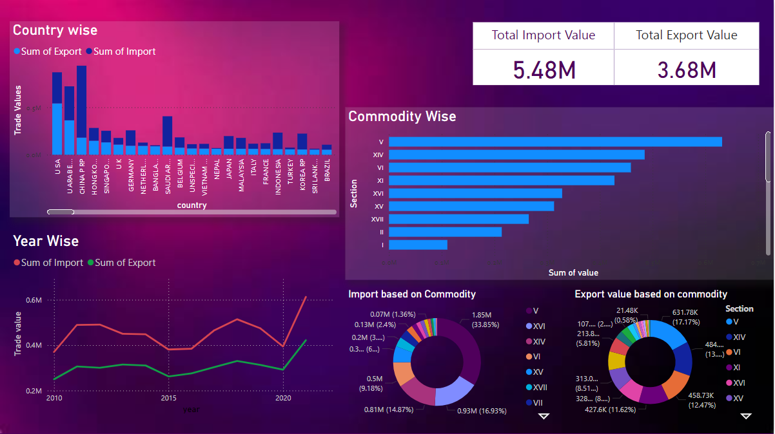

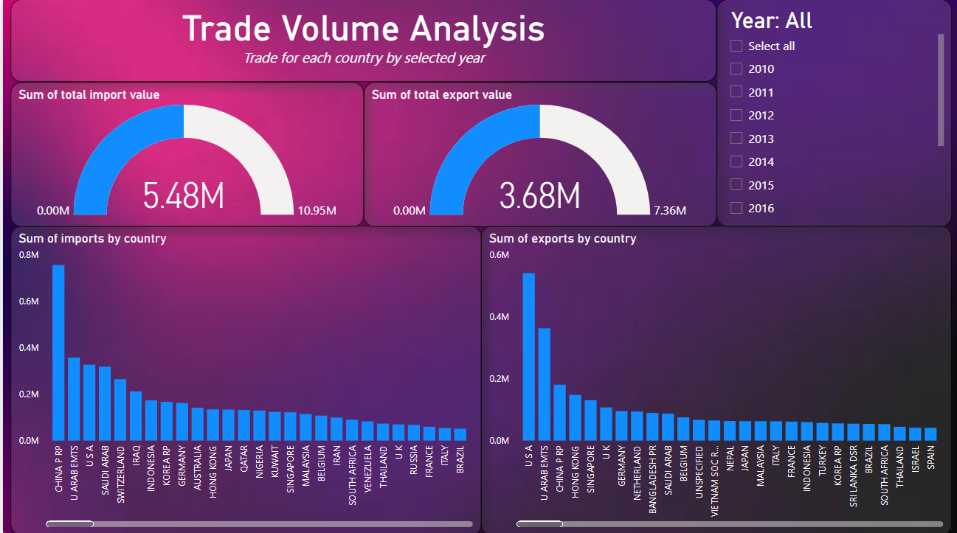

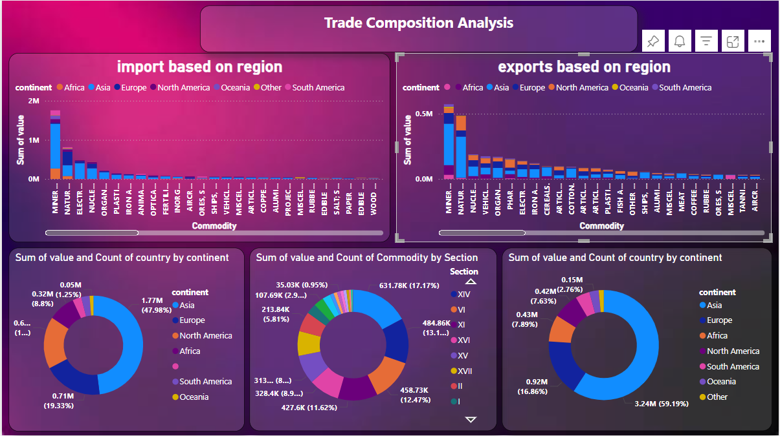

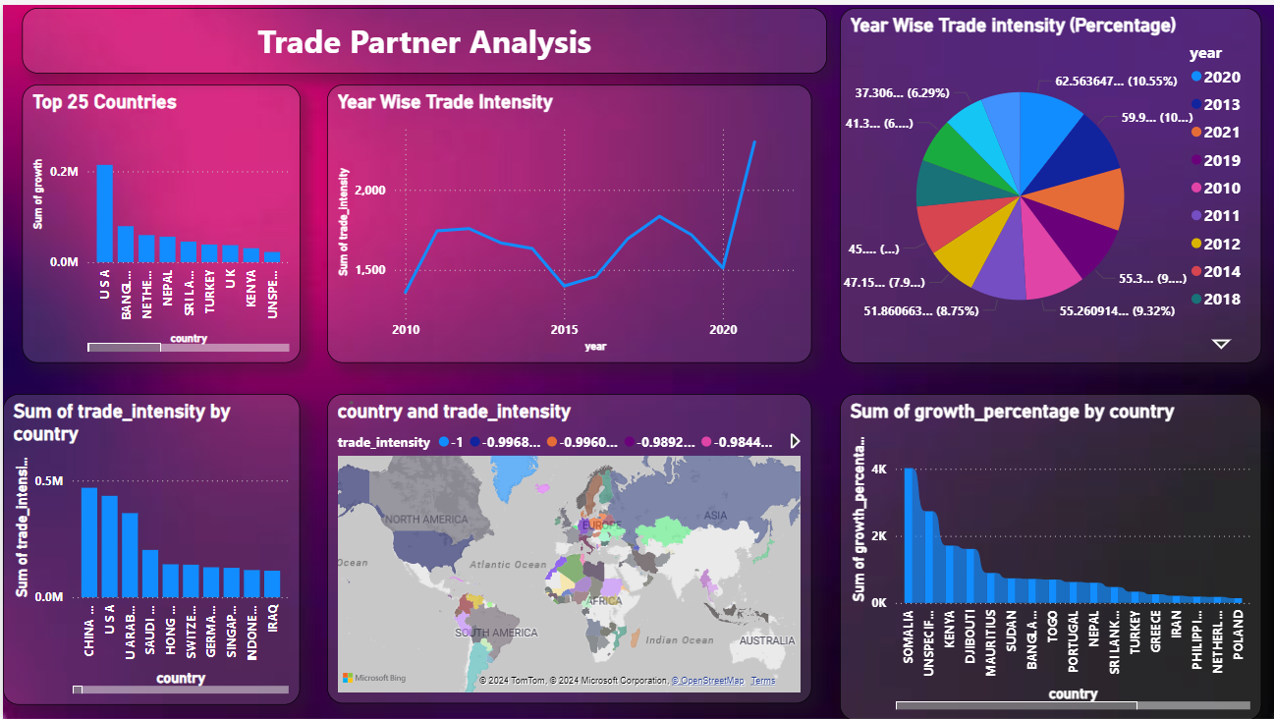

**Learning:**

- Developed strong skills in Power BI and data analysis.

- Enhanced teamwork abilities.

- Used Jira software for planning and tracking projects.

- Worked with the GitHub platform for sharing code.

- Gained valuable experience in the field of data analytics.

**Contributors:**

Dhruvi Desai

Preet Shah

Harsh Vaghamashi

Amulakh Desai

Umang Chauhan

**Guided By Alakh Pandya**